Chapter 12, Solution 32.

Design a problem to help other students to better understand power in a balanced three-phase system.

Although there are many ways to solve this problem, this is an example based on the same kind of problem asked in the third edition.

Problem

A balanced wye load is connected to a 60-Hz three-phase source with V_{ab} = 240∠0˚V. The load has lagging pf =0.5 and each phase draws 5 kW. (a) Determine the load impedance Z_{Y}. (b) Find I_{a}, I_{b}, and I_{c}.

Solution

(a) 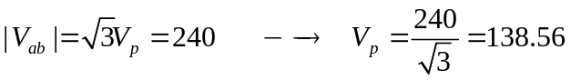
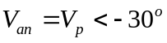
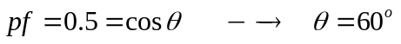
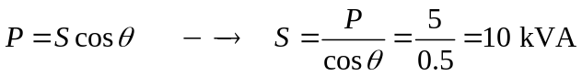
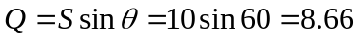
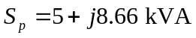
But
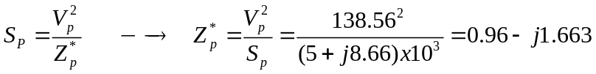
Z_{p} = [0.96 + j1.663] Ω
(b) 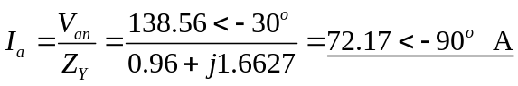= 72.17∠–90° A
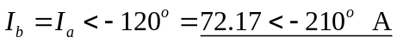= 72.17∠150° A
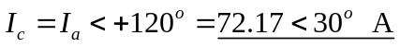= 72.17∠30° A

